**Practice project**

Retrieving the Product Details Using the Product ID

Output:

Products table in database

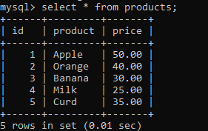

Getting id from user

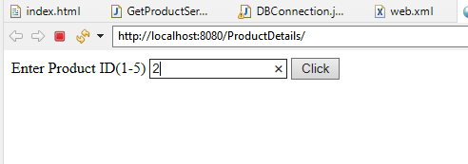

Product details

